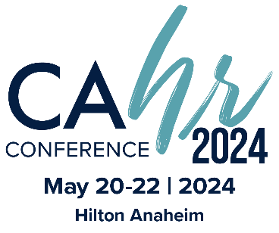
Dear [Immediate Supervisor/Board],
The California HR Conference® is the foremost HR event in California. For education, networking and professional development, this event simply has no equal. I believe my participation is critical to bringing new ideas and approaches to our organization and furthering my professional development. I would like to request approval to attend.
The event is May 20-22, 2024 in Anaheim and will also be streaming. I’ll be among 2,000+ industry professionals to hear HR experts and innovators discuss employment law and legislation, strategic management, leadership development, and global HR. I’ll also learn practical tools pertaining to compensation and benefits, talent management, and diversity. The exposition offers opportunities for networking and business that could have a positive impact on our organization. By meeting with industry partners, I can find solutions to everyday issues and strengthen existing relationships. A full schedule of events will be available at cahrconference.org.
I plan to attend the following (tracks or sessions) to strengthen my professional development. (List the tracks or sessions you plan to attend, the learner outcomes, and how they will benefit you, your team, and your organization.) ____________________________________________________________________________________________________________________________________________________________________________________________________________________________________________________________
Following are exhibitors I plan to speak with that I think can help our organization: ____________________________________________________________________________________________________________________________________________________________________________________________________________________________________________________________
Here are my projected costs for attending the California HR Conference®:
Registration Fee $ xx.xx

This investment will pay off in more efficient practices, proven solutions, new insights, and ideas. After returning, I will summarize key takeaways and recommended actions.
I would appreciate your approval of this request and will work to ensure we get the full value of this event.
[Your Name]

