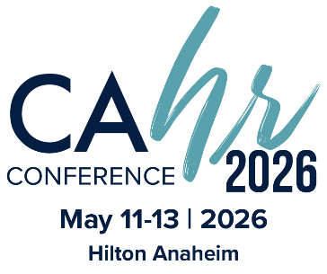

Dear [Immediate Supervisor/Board],

The California HR Conference® is the foremost HR event in California known for its unparalleled education, networking, and professional development opportunities I believe my participation in this event is essential for bringing fresh ideas and approaches to our organization and advancing my professional growth. I am requesting approval to attend the conference, which will take place from May 11-13, 2026, in Anaheim, with an option to attend virtually.

By attending CAHR26, I'll join 1,000+ HR professionals to learn from industry experts on key topics like employment law, leadership, and global HR. The conference offers practical tools in compensation, talent management, and DEI practices, directly benefiting our HR strategy and operational efficiency. Networking with leaders and potential partners will foster new collaborations and solutions. I'll also explore exhibitors' products and services to streamline operations and reduce costs. A full schedule of events will be available at [cahrconference.org](http://www.cahrconference.org/).

I plan to attend the following (tracks or sessions) to strengthen my professional development. (List the tracks or sessions you plan to attend, the learner outcomes, and how they will benefit you, your team, and your organization.) ____________________________________________________________________________________________________________________________________________________________________________________________________________________________________________________________

Following are exhibitors I plan to speak with that I think can help our organization: ____________________________________________________________________________________________________________________________________________________________________________________________________________________________________________________________

Here are my projected costs for attending the California HR Conference®:

Registration Fee $ xx.xx

This investment will result in more efficient practices, proven solutions, and new insights that will benefit our team. Upon my return, I am committed to providing a detailed report of key takeaways and recommended actions to ensure we maximize the value of this event.

I would greatly appreciate your approval of this request and will work diligently to ensure that our organization reaps the full benefits of my attendance at CAHR26.

[Your Name]